CodeWorld: An LLM-Powered Interactive Graph-RAG System for Software Repository Understanding

What you're building :
A developer uploads a software repository.
CodeWorld automatically:
- Reads the source code
- Understands its structure
- Extracts files, classes, functions and dependencies
- Builds a code knowledge graph
- Creates embeddings of useful code/documentation
- Stores both structural and semantic information
- Uses an LLM + hybrid retrieval to answer questions
- Visually shows the relevant parts of the codebase
- Performs dependency/impact analysis
- Optionally lets users explore the repository as an interactive graph
The final experience should feel like:
“Google Maps + ChatGPT for a software codebase.”

Your system has 6 major capabilities.

Capability 1 — Repository understanding
Input:
GitHub URL
Output:
structured representation of the repository.

Capability 2 — Code knowledge graph
Represent:
Repository
├── Module
│ ├── File
│ │ ├── Class
│ │ │ └── Method
│ │ └── Function
and relationships:
IMPORTS
CALLS
CONTAINS
INHERITS
IMPLEMENTS
DEPENDS_ON
TESTS

Capability 3 — Semantic code search
User asks:
"Where is password validation handled?"
The system finds relevant code based on meaning, not just exact keywords.

Capability 4 — Natural-language codebase Q&A
Examples:
"How does authentication work?"
"Where is the database connection created?"
"What calls process_order()?"
"Explain this class."

Capability 5 — Impact analysis
User selects:
authenticate()
Then asks:
"What could be affected if I modify this?"
System traces dependencies and presents them visually.

Capability 6 — Interactive visualization
The user can explore:
Repository
↓
Modules
↓
Files
↓
Classes
↓
Functions
and see relationships.

Final project _ 7th sem

GPT link - https://chatgpt.com/share/6ab0b1c6-ce3c-83ee-87f9-9aac78bf37b1

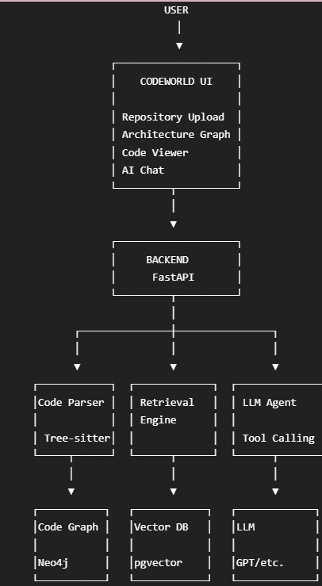

Brain 1 — Code understanding
What is inside the repository?

Brain 2 — Retrieval
What information is relevant to this question?

Brain 3 — LLM
How do I reason over that information and explain it?
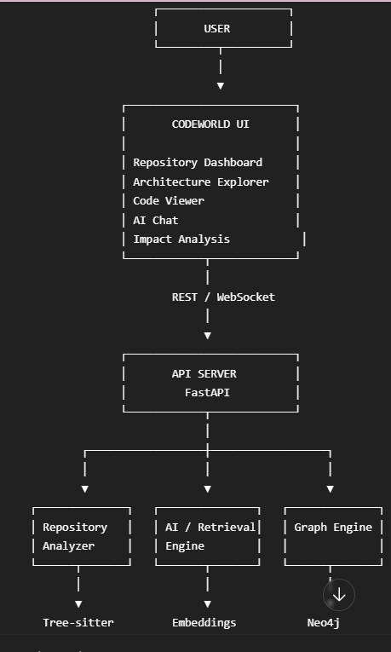
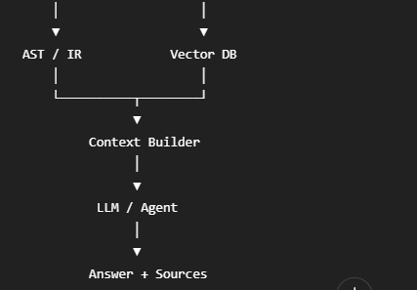
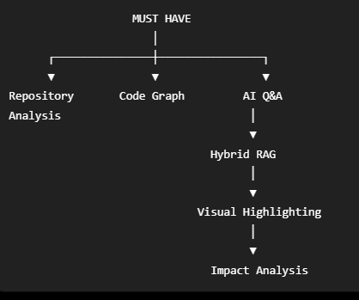
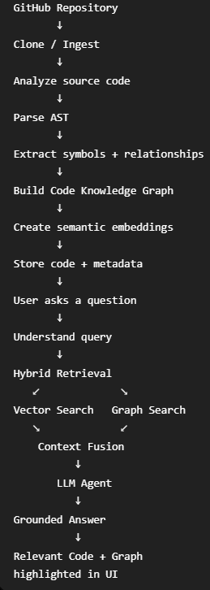
3 core layers:

ENGINE A — Code Intelligence
Question:
"What is inside this codebase?"
Responsible for:
- parsing
- AST
- symbols
- functions
- classes
- imports
- calls
- dependencies
- graph

ENGINE B — AI Intelligence
Question:
"What does the user want and what information should we retrieve?"
Responsible for:
- embeddings
- vector search
- Graph-RAG
- query understanding
- LLM
- tool calling
- agent
- answer generation

ENGINE C — Visualization
Question:
"How do we let a human understand all this?"
Responsible for:
- architecture graph
- code viewer
- search
- AI chat
- node highlighting
- impact visualization

📥 STAGE 1 — REPOSITORY INGESTION
This is where everything begins.
User enters:
https://github.com/example/project
Backend receives it.

Process
GitHub URL
↓
Validate URL
↓
Clone repository
↓
Create repository ID
↓
Scan files
↓
Filter irrelevant files
↓
Send supported files to parser
Ignore:
.git/
node_modules/
venv/
__pycache__/
dist/
build/
binary files
images
large generated files
Store:
repository_id
repository_name
url
language(s)
file_count
status
created_at

5. 🔍 STAGE 2 — FILE ANALYSIS
For every source file:
File
│
├── path
├── language
├── size
├── imports
├── classes
├── functions
├── variables
└── relationships
Example:
auth/service.py

Language: Python

Classes:
AuthService

Functions:
authenticate()
refresh_token()

Imports:
jwt
UserRepository

6. 🌳 STAGE 3 — AST PARSING
This is where Tree-sitter comes in.
You don't want an LLM guessing:
"I think this function calls that function."
You want deterministic code analysis wherever possible.
Source Code
↓
Tree-sitter
↓
AST
↓
AST Traversal
↓
Structured Symbols
For example:
class AuthService:
def authenticate(self, user):
return verify(user)
Extract:
Class:
AuthService

Method:
authenticate

Calls:
verify

7. 🕸️ STAGE 4 — BUILD THE CODE KNOWLEDGE GRAPH
This is one of your project's biggest technical components.

Nodes
Repository
Module
File
Class
Function
Method
API
Test

Relationships
CONTAINS
IMPORTS
CALLS
INHERITS
IMPLEMENTS
DEPENDS_ON
TESTS
Example:
AuthController
│
│ CALLS
▼
AuthService
│
│ CALLS
▼
UserRepository
│
│ ACCESSES
▼
Database
Store this in a graph database such as Neo4j.

8. 🧬 STAGE 5 — CREATE CODE CHUNKS
Now you need the AI retrieval side.
Don't just split code every 500 characters.
That's bad code retrieval.
Prefer logical units:
README section
Function
Method
Class
Documentation
Comment
Module
Each chunk gets metadata:
{
"chunk_id": "123",
"repository_id": "abc",
"file": "auth/service.py",
"symbol": "authenticate",
"type": "function",
"start_line": 15,
"end_line": 31,
"code": "..."
}

9. 🧠 STAGE 6 — EMBEDDINGS
Each code chunk goes through an embedding model.
Conceptually:
authenticate()
↓
Embedding Model
↓
[0.21, -0.72, 0.14, ...]
Store:
vector
+
code
+
metadata
in your vector store.
You can use:
- pgvector
- Qdrant
- Chroma
For your project, PostgreSQL + pgvector is attractive because you can keep relational metadata and vectors together.

10. 🔎 STAGE 7 — SEMANTIC SEARCH
User:
"Where do we check whether a password is valid?"
Query gets embedded.
Vector search finds:
PasswordHasher.verify()
authenticate()
validate_credentials()
The system returns the top relevant chunks.

11. 🕸️ STAGE 8 — GRAPH SEARCH
Now suppose the user asks:
"What calls authenticate?"
Semantic search isn't enough.
You query the graph:
authenticate()
↑
│
LoginService
↑
│
LoginController
Return:
LoginService
LoginController

12. 🔥 STAGE 9 — HYBRID RETRIEVAL
This is the heart of CodeWorld.
You combine:

Semantic retrieval
"What code is conceptually relevant?"
with:

Graph retrieval
"What code is structurally related?"
So:
QUERY
│
┌──────────┴──────────┐
▼ ▼
Semantic Search Graph Search
│ │
▼ ▼
Relevant Code Dependencies
│ │
└──────────┬──────────┘
▼
Context Fusion
│
▼
LLM
This gives you your major technical research component:
Does hybrid retrieval provide better codebase understanding than semantic retrieval alone?

13. 🤖 STAGE 10 — LLM RESPONSE GENERATION
The LLM receives:
User Question

+

Relevant code

+

Relevant graph relationships

+

File/symbol metadata
Prompt instructs it:
- answer only from retrieved context
- cite files/functions
- don't invent information
- state when information is insufficient
Example:
Question: How does login work?
LLM receives:
LoginController.login()
calls AuthService.authenticate()

AuthService.authenticate()
calls PasswordHasher.verify()

AuthService.authenticate()
calls JWTService.generate_token()
Answer:
Login begins in LoginController.login(), which calls AuthService.authenticate(). The authentication service verifies the password and generates a JWT after successful validation.
Sources:
auth/controller.py:20
auth/service.py:45
auth/jwt.py:18

14. 🧑‍💻 STAGE 11 — AGENTIC LAYER
Now we make the AI smarter.
Give the LLM tools.
search_code()
find_symbol()
find_callers()
find_callees()
get_function()
get_file()
trace_dependencies()
find_tests()
Now user asks:
"Explain the complete authentication flow."
LLM can do:
1. find_symbol("login")
2. get_function(login)
3. find_callees(login)
4. find_callees(authenticate)
5. find_callees(verify_password)
6. find_callees(generate_token)
7. retrieve source
8. synthesize explanation
That's an agentic workflow.

15. 💥 STAGE 12 — IMPACT ANALYSIS
This is one of your best features.
User selects:
authenticate()
CodeWorld finds:

Direct callers
LoginService
AdminLoginService

Indirect callers
LoginController
AdminController

Tests
test_login.py
test_admin_login.py

API endpoints
POST /login
POST /admin/login
Then show:
authenticate()
/ \
/ \
LoginService AdminLoginService
│ │
▼ ▼
LoginController AdminController
│ │
▼ ▼
POST /login POST /admin/login

16. 🖥️ STAGE 13 — THE FRONTEND
Your UI should have roughly four screens.

Screen 1 — Home
CODEWORLD

Understand any codebase.

[ GitHub Repository URL ]

ANALYZE

Screen 2 — Repository Dashboard
Repository: project-x

Files 183
Classes 92
Functions 641
Dependencies 1284

[Architecture] [Files] [AI Assistant]

Screen 3 — Architecture Explorer
Interactive graph.
Click:
AuthService
Side panel:
AUTH SERVICE

File:
src/auth/service.py

Methods:
authenticate()
refresh_token()
logout()

Dependencies:
UserRepository
JWTService

Screen 4 — AI Assistant
┌────────────────────────────────────┐
│ CODEWORLD AI
│
│ How does authentication work?
│
│ Authentication starts at...
│
│ Sources:
│ auth/controller.py
│ auth/service.py
│
│ ────────────────────────────────
│ Ask your codebase...
└────────────────────────────────────┘

Your course | How CodeWorld uses it | Importance
Working with LLMs | LLM, RAG, embeddings, Graph-RAG, tool calling, AI agent | ⭐⭐⭐⭐⭐
Computer Vision Fundamentals | Not required for the core project | ⭐
Computer Graphics Fundamentals | Interactive code/dependency visualization, graph rendering, optional 3D representation | ⭐⭐⭐
Virtual Reality | Optional VR exploration of the codebase | ⭐⭐

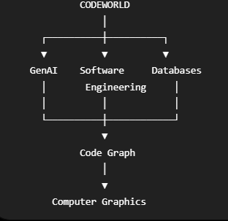
Okayyy listen 😭🤝 Let’s divide the entire CodeWorld project between Thanyaa, Harshitha, and Kavya so that everyone has clear ownership, their own modules, and enough work to explain during the final-year project review and viva.
The rule is simple: each person owns a major part of the project from development to testing. No one is just doing the PPT or UI.

CodeWorld — Complete 3-Person Work Division

Person 1 — Thanyaa
Code Analysis & Knowledge Graph
Main responsibility: Make the system understand the code inside a repository.
- Build the repository upload and extraction logic for ZIP files and GitHub repositories.
- Filter unnecessary folders such as .git, venv, and node_modules.
- Use Tree-sitter to parse Python source code.
- Extract functions, classes, methods, imports, and line numbers.
- Identify relationships such as function calls, imports, inheritance, and tests.
- Build the code knowledge graph using Neo4j or NetworkX.
- Implement graph queries to find callers, callees, dependencies, and related files.
- Build the backend logic for identifying potentially affected files when code changes.
- Write unit tests for parsing and graph construction.
Files owned: code_analyzer/, graph/, parser/, ingestion/
Final deliverable: Upload a repository and generate a searchable graph showing how its code components are connected.

Person 2 — Harshitha
GenAI, Hybrid RAG & AI Agent
Main responsibility: Make the system answer questions about the repository intelligently.
- Split source code into meaningful chunks, such as functions, classes, and documentation.
- Generate embeddings for code chunks.
- Store embeddings in a vector database such as Qdrant or pgvector.
- Implement semantic search to find relevant code.
- Combine vector search with Thanyaa’s knowledge-graph retrieval to build Hybrid Graph-RAG.
- Connect an LLM API to explain code in natural language.
- Make answers cite the relevant file names and source line numbers.
- Build an AI agent that can use tools to find symbols, inspect functions, and trace dependencies.
- Generate AI explanations for potential code-change impacts.
- Evaluate answer quality, retrieval accuracy, and citation correctness.
Files owned: ai_engine/, retrieval/, agent/, evaluation/
Final deliverable: A user can ask, “Where is user authentication handled?” and receive a grounded explanation with relevant code references.

Person 3 — Kavya
Frontend, API Integration & Visualization
Main responsibility: Turn the analysis and AI modules into a working application.
- Build the frontend using React.
- Create the repository upload page and analysis-progress screen.
- Build the repository dashboard and file navigation.
- Create the interactive architecture graph using React Flow.
- Display functions, classes, files, and relationships as clickable nodes.
- Build a source-code viewer with line numbers.
- Create the AI chat interface and display answers from Harshitha’s module.
- Make source citations clickable so users can open the relevant code.
- Highlight graph nodes related to an AI answer.
- Build the impact-analysis panel to display affected files and dependencies.
- Integrate all modules through FastAPI endpoints.
- Handle errors, loading states, environment configuration, and deployment.
- Prepare the final demo workflow and application documentation.
Files owned: frontend/, backend/api/, backend/main.py, docker-compose.yml
Final deliverable: A complete application where users upload a repository, explore its graph, ask AI questions, and inspect potential code-change impacts.

How the 3 parts connect
Kavya — User Interface
User uploads a repository and asks a question
Thanyaa
Parses source code and builds the knowledge graph.
Harshitha
Retrieves relevant code and generates grounded AI answers.
Kavya displays the result
AI explanation + cited source code + highlighted graph + impact analysis

Exact task division by project phase
Phase | Thanyaa | Harshitha | Kavya
Weeks 1–2 | Repository ingestion and parser prototype | Embeddings and basic semantic search | React UI and FastAPI skeleton
Weeks 3–4 | Symbol extraction and graph construction | Vector database and retrieval | Upload page and graph visualization
Weeks 5–6 | Graph queries and dependency relationships | LLM integration and grounded answers | Integrate real backend data
Weeks 7–8 | Improve graph and caller/callee queries | Hybrid Graph-RAG and source citations | AI chat and clickable source references
Weeks 9–10 | Impact-analysis data and tests | AI agent and impact explanations | Impact-analysis UI and graph highlighting
Weeks 11–12 | Parser and graph testing | RAG and citation evaluation | End-to-end integration and error handling
Weeks 13–14 | Graph accuracy experiments | Compare retrieval methods and evaluate results | Usability testing and performance improvements
Weeks 15–16 | Technical documentation and viva | AI methodology, results, and viva | Deployment, final demo, and report integration
This assumes a 16-week schedule; adjust the weeks to match your college deadline.

Shared work — all three must do this
Even with separate ownership, everyone should contribute to:
- Project report: Each person writes their own module, implementation, results, and testing sections.
- Testing: Test the complete application together, not just individual modules.
- GitHub: Each person commits their own code and reviews at least some of the others’ code.
- Presentation: Each person explains their own module and understands the overall architecture.
- Viva: Everyone should be able to explain the full workflow, including how the graph, RAG, LLM, and UI work together.

Important rules so the project doesn't become a mess
- Kavya does not build the AI engine herself. She integrates the modules through agreed APIs.
- Thanyaa and Harshitha agree on data formats early. Harshitha needs graph-query results from Thanyaa in a predictable format.
- Build a small working version first. Start with Python repositories; add JavaScript/TypeScript only after the core pipeline works.
- Keep 3D/VR optional. The strongest core project is the working knowledge graph, Hybrid Graph-RAG, cited answers, and impact analysis.
- No fake parallel work. Everyone should have code, tests, and a demonstrable deliverable.

The final ownership summary
- Thanyaa: Code understanding — parsing, symbol extraction, graph construction, dependency and impact data.
- Harshitha: AI intelligence — embeddings, vector search, Hybrid Graph-RAG, LLM answers, agent, evaluation.
- Kavya: Application experience — React UI, graph visualization, API integration, source viewer, deployment.
This division gives each of you a substantial technical module to demonstrate. The most important first step is to agree on the API and data schemas together, so all three modules fit into one application instead of becoming three separate mini-projects.

